In this lab we need to deploy application via the GitOps way using Harness CD

First we sign up to Harness and we choose Kubernetes with GitOps deployment type and we connect to Harness:

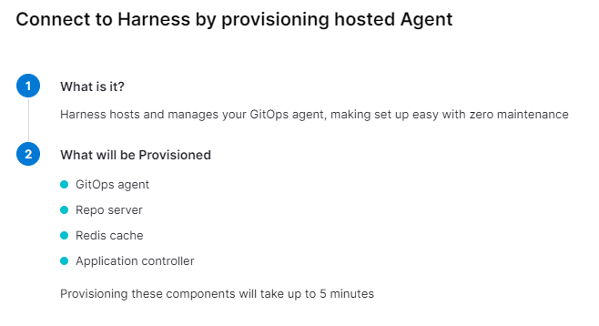

After the agent is installed next is to provide simple details like source, authentication and Git details.

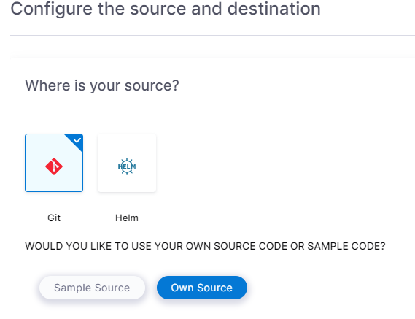

The repo link is added and the repo is public and no authentication is needed. I have used the repo from the exercise

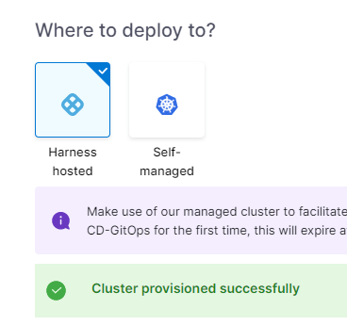

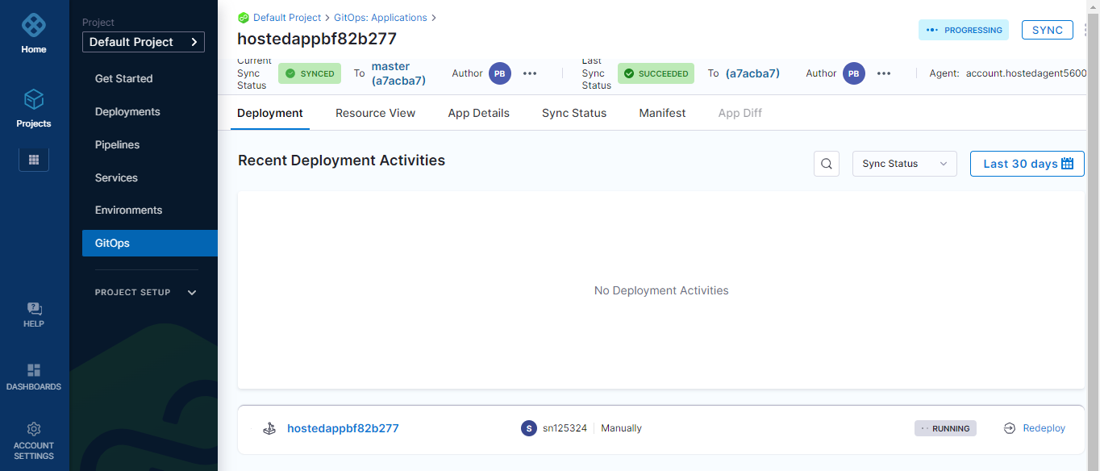

This is the page we get after we click Create and Syns App. It is a GitOps Dashboard

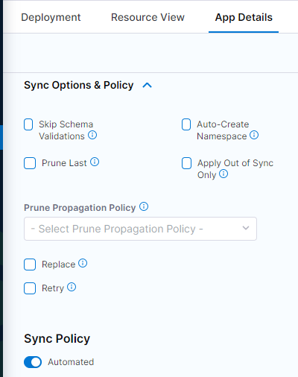

Here the Sync Policy is changed to Automated. When any changes happen to the GitHub repo, the GitOps agent will pick those changes automatically and syncing will happen in an automated fashion

If we open the app we can see 5 replicas:

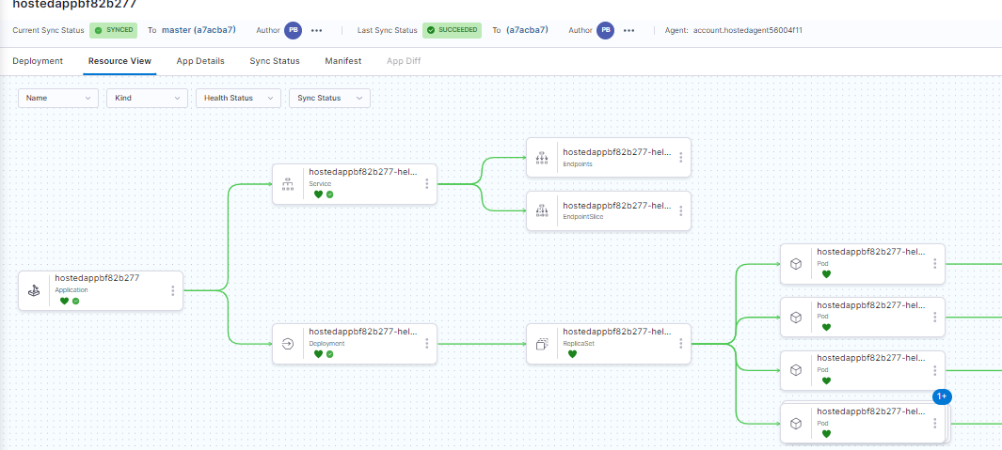

And if we change the values.yaml file for example we change the number of replicas to 6, GitOps agent will see this difference and picks it up, we sync again and now we have 6 replicas

